

International School

**Capstone Project 1**

CMU-SE 450/CMU-IS 450/CMU-CS450

**User Interface**

**Version 1.1**

**Date: October 20, 2020**

**UNIVERSITY REVIEWS**

**Submitted by**

**Nguyen Van Minh Toi**

**Nguyen Huu Thien**

**Ho Xuan Sang**

**Huynh Thi Quy Thuong**

**Approved by**

**Project Plan Review Panel Representative:**

Name Signature Date

**Capstone Project 1- Mentor:**

Name Signature Date

**Dr.Ha Thi Nhu Hang**

**PROJECT INFORMATION**

|  |  |  |  |
| --- | --- | --- | --- |
| **Project acronym** | URs | | |
| **Project Title** | University reviews | | |
| **Start Date** | August 13, 2020 | End Date | December 05, 2020 |
| **Lead Institution** | International School, Duy Tan University | | |
| **Project Mentor &contact details** | Dr. Ha Thi Nhu Hang  Email: [hatnhuhang@duytan.edu.vn](mailto:hatnhuhang@duytan.edu.vn)  Tel: 0707121301 | | |
| **Product Owner** | Toi, Nguyen Van Minh  Email: [minhtoi2799@gmail.com](mailto:minhtoi2799@gmail.com)  Tel: 0902257132 | | |
| **Scrum Master** | Thien, Nguyen Huu  Email: [huuthiennguyen1999@gmail.com](mailto:huuthiennguyen1999@gmail.com)  Tel: 0783533812 | | |
| **Team members** | **Name** | **Email** | **Tel** |
| Toi, Nguyen Van Minh | minhtoi2799@gmail.com | 0902257132 |
| Thien, Nguyen Huu | huuthiennguyen1999@gmail.com | 0783533812 |
| Sang, Ho Xuan | hsang19999@gmail.com | 0362982905 |
|  | Thuong, Huynh Thi Quy | quythuong0405@gmail.com | 0333633770 |

|  |  |  |  |
| --- | --- | --- | --- |
| **DOCUMENT NAME** | | | |
| **Document Title** | User Interface Document | | |
| **Author(s)** | Thuong, Huynh Thi Quy | | |
| **Role** | Team members | | |
| **Date** | 15 – Oct – 2020 | **File name:** | User Interface v1.0 |
| **URL** |  | | |
| **Access** |  | | |

|  |  |  |  |
| --- | --- | --- | --- |
| **REVISION HISTORY** | | | |
| **Version** | **Person** | **Date** | **Description** |
| **1.0** | Thuong, Huynh Thi Quy | 15 – Oct – 2020 | Draft |
| **1.1** | Thien, Nguyen Huu | 20-Oct-2020 | Update |

|  |  |  |  |
| --- | --- | --- | --- |
| **Document Approval**  The following signatures are required for approval of this document | | | |
| **Mentor** | Dr. Ha Thi Nhu Hang | **Signature:** |  |
| **Date:** |  |
| **Signature:** |  |
| **Date:** |  |
| **Product Owner** | Nguyen Van Minh Toi | **Signature:** |  |
| **Date:** |  |
| **Scrum Master** | Nguyen Huu Thien | **Signature:** |  |
| **Date:** |  |
| **Team Member(s)** | Huynh Thi Quy Thuong | **Signature:** |  |
| **Date:** |  |
| Ho Xuan Sang | **Signature:** |  |
| **Date:** |  |

Contents

**I.** **Introduction:** 5

1. Purpose 5

2. Scope 5

**II.** **List of User Interface:** 5

1. User 5

2. University 6

3. Admin 6

**III.** **Describe User Interface:** 7

**1.** **User** 7

1.1 Login page 7

1.2 Register page 9

1.3 Home page 10

1.4 Page not found 12

1.5 Coming soon 13

1.6 Information about the university page 14

1.7 Specialized page 17

1.8 Cooperation page 18

1.9 Galary page 20

1.10 Topic detail page 21

1.12 Comment page 23

1.13 Post topic page 25

1.14 Edit personal information 26

1.15 Personal page 28

**2.** **University** 29

2.1 Login 29

2.2 Main page university 30

2.3 Edit information 31

**3.** **Admin** 32

3.1 Login 32

3.2 Manage account 33

3.3 Manage comment 34

3.4 Manage galaries 35

3.5 Manage partners 35

3.6 Manage topic 36

3.7 Creat account 37

1. **Introduction:**
2. Purpose

* This document helps to better understand the interface of the Comment Scraper Tool, detailed specification components and function of the system.
* With this document, the development team can understand detail the structure and composition to create a consistent and complete system.

1. Scope

* Overview of the stages and modules of the system.
* Create complete interfaces and describe them clearly.

1. **List of User Interface:**
   1. User

|  |  |  |
| --- | --- | --- |
| **User Interface ID** | **UI Name** | **Description** |
| UI-01 | Login | This is login page of User |
| UI-02 | Register | This is the University Reviews user account registration page |
| UI-03 | Home page | This is a page that displays information for the universities in order of interaction from more to less and shows a filter of group positions. |
| UI-04 | Page not found | This page displays when the system does not exist data requested by the user when entering the system |
| UI-05 | Coming soon | This is the page when a feature is improving |
| UI-06 | Information about the university | This is the page that provides information about the university |
| UI-07 | Specialized | This is the page showing all the disciplines the university can offer |
| UI-10 | Cooperation | This is a page that shows all the partners the school is working with |
| UI-09 | Gallery | This is a page showing pictures of university activities |
| UI-10 | Topic detail | This is the page that shows the university reviews |
| UI-11 | Comment | This is the page where users can view comments and post comments |
| UI-12 | Post topic | This is the page where users can post topics and view topics |
| UI-13 | Edit personal information | This is the page to edit the user's information |
| UI-14 | Personal | This is the page display the user account information |

* 1. University

|  |  |  |
| --- | --- | --- |
| **User Interface ID** | **UI Name** | **Description** |
| UI-13 | Login | This is the login page of Admin University |
| UI-14 | Main page University | This is main page of Admin University |
| UI-15 | Edit information | This is a page that allows the Admin of University to edit information about the university |

* 1. Admin

|  |  |  |
| --- | --- | --- |
| **User Interface ID** | **UI Name** | **Description** |
| UI-16 | Login | This is the login page of Admin University |
| UI-17 | Manage account | This is main page of Admin system |
| UI-18 | Manage comment | Management all user’s comment |
| UI-19 | Manage detail major | List the majors for each university |
| UI-20 | Manage galaries | This is manage detail, it lists all the action of the university |
| UI-21 | Manage partners | List of partners of all universities |
| UI-22 | Manage topic | List of university reviews |
| UI-23 | Creat account | Create accounts for university admins or system admins |

1. **Describe User Interface:**
2. **User**

### 1.1 Login page



|  |  |  |  |  |  |
| --- | --- | --- | --- | --- | --- |
| **ID** | **Condition** | **Null** | **Control Type** | **Target** | **Notes** |
| 1 | Click |  | Text Box-User name | Enter the user name |  |
| 2 | Click |  | Text Box-Password | Enter the password |  |
| 3 | Click |  | Link | Password retrieval | If users do not remember the password to log into their account, click on "Forgot Password". |
| 4 | Click |  | Button | Login to the system |  |
| 5 | Click |  | Icon | Login by the Facebook account | When users want to login with a social network account |
| 6 | Click |  | Icon | Login by the Gmail account |
| 7 | Click |  | Icon | Login by the Instagram account |
| 8 | Click |  | Link | Go to the registration page |  |

### 1.2 Register page



|  |  |  |  |  |  |
| --- | --- | --- | --- | --- | --- |
| **ID** | **Condition** | **Null** | **Control Type** | **Target** | **Notes** |
| 1 | Click |  | Text Box | Enter the account name |  |
| 2 | Click |  | Text Box | Enter the email account |  |
| 3 | Click |  | Text Box | Enter the password |  |
| 4 | Click |  | Text Box | Confirm password | Check the accuracy of the password |
| 5 | Click |  | Button | Complete registration |  |

### 1.3 Home page

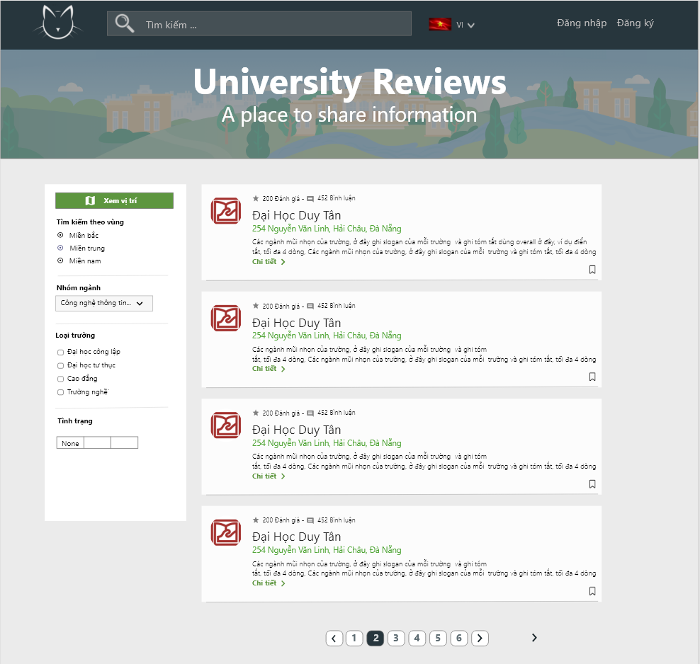

|  |  |  |  |  |  |
| --- | --- | --- | --- | --- | --- |
| **ID** | **Condition** | **Null** | **Control Type** | **Target** | **Notes** |
| 1 | Click |  | Link | Go to the Home page |  |
| 2 | Click |  | Text | Enter the information to look for |  |
| 3 | Click |  | Button | Look for information |  |
| 4 | Click |  | Combo Box | Select the language to use for the web |  |
| 5 | Click |  | Link | Go to the login page |  |
| 6 | Click |  | Link | Go to the registration page |  |
| 7 | Click |  | Button | Select the area |  |
| 8 | Click |  | Combo Box | Select industry group |  |
| 9 | Click |  | Button | Select a university type |  |
| 10 | Click |  | Button | Search information by filter |  |
| 11 | Click |  | Link | See detailed information about the university |  |
| 12 | Click |  | Button | Move to the next page or back or move to the required page number | The user who wants to see more about the fields currently displayed on the home page or to return to the old page choose "next" or "previous" |

### 1.4 Page not found

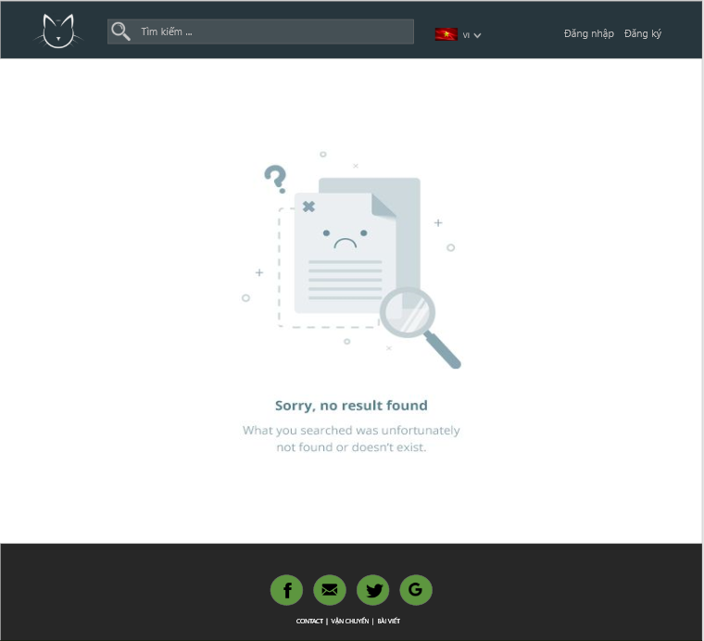

|  |  |  |  |  |  |
| --- | --- | --- | --- | --- | --- |
| **ID** | **Condition** | **Null** | **Control Type** | **Target** | **Notes** |
| 1 | Click |  | Logo | Go to the Home page |  |

### 1.5 Coming soon

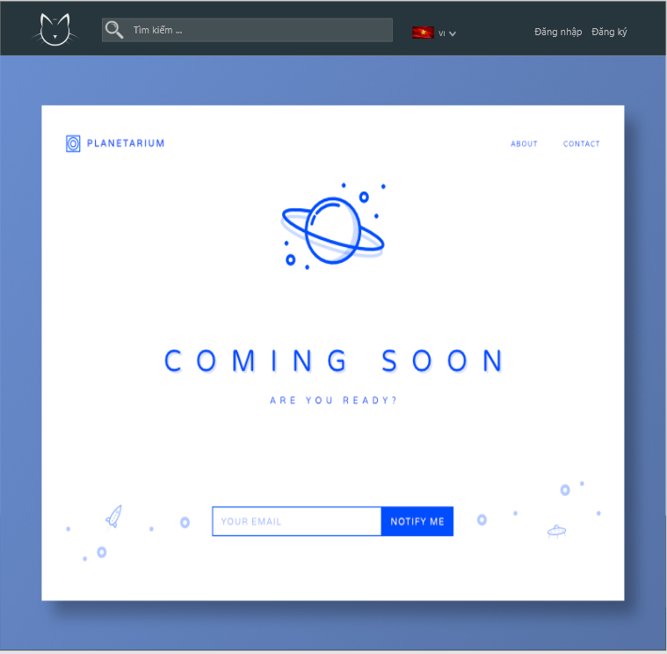

|  |  |  |  |  |  |
| --- | --- | --- | --- | --- | --- |
| **ID** | **Condition** | **Null** | **Control Type** | **Target** | **Notes** |
| 1 | Click |  | Logo | Go to the Home page |  |

### 1.6 Information about the university page

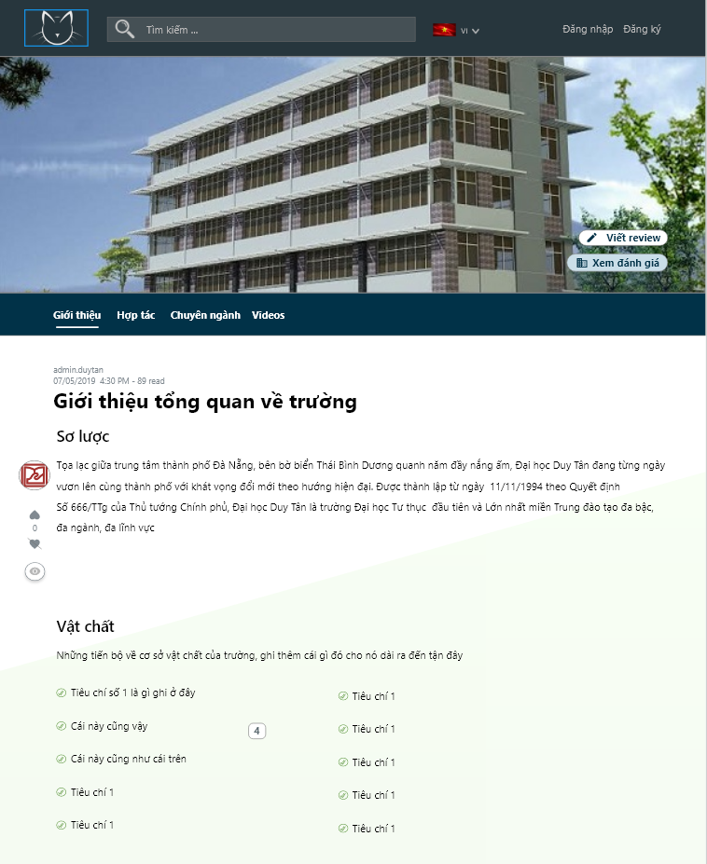

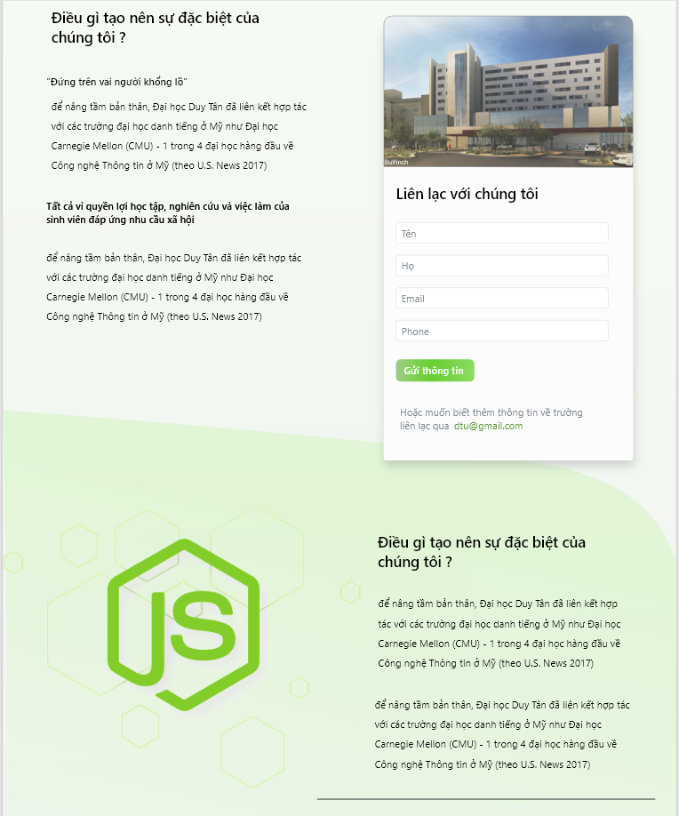

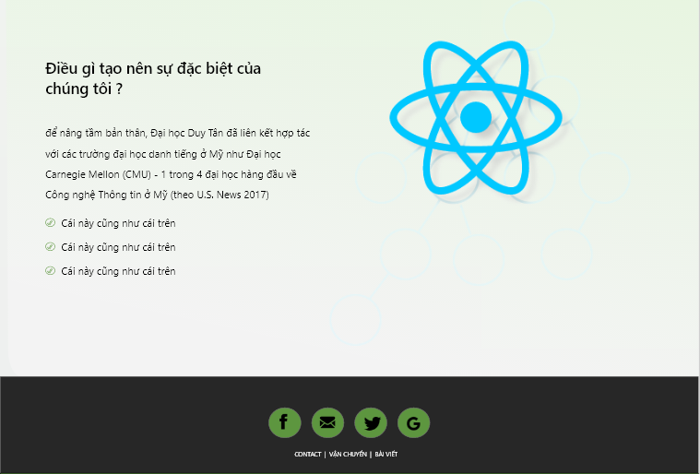

|  |  |  |  |  |  |
| --- | --- | --- | --- | --- | --- |
| **ID** | **Condition** | **Null** | **Control Type** | **Target** | **Notes** |
| 1 | Click |  | Link | An overview of the university |  |
| 1.1 | Click |  | Text box | Enter first name | Users leave information to contact the University |
| 1.2 | Click |  | Text box | Enter last name |
| 1.3 | Click |  | Text box | Enter phone number |
| 1.4 | Click |  | Button | Send information |
| 2 | Click |  | Link | The specialized university admission training |  |
| 3 | Click |  | Link | Cooperation programs |  |
| 4 | Click |  | Link | All activities are held at the university |  |

### 1.7 Specialized page

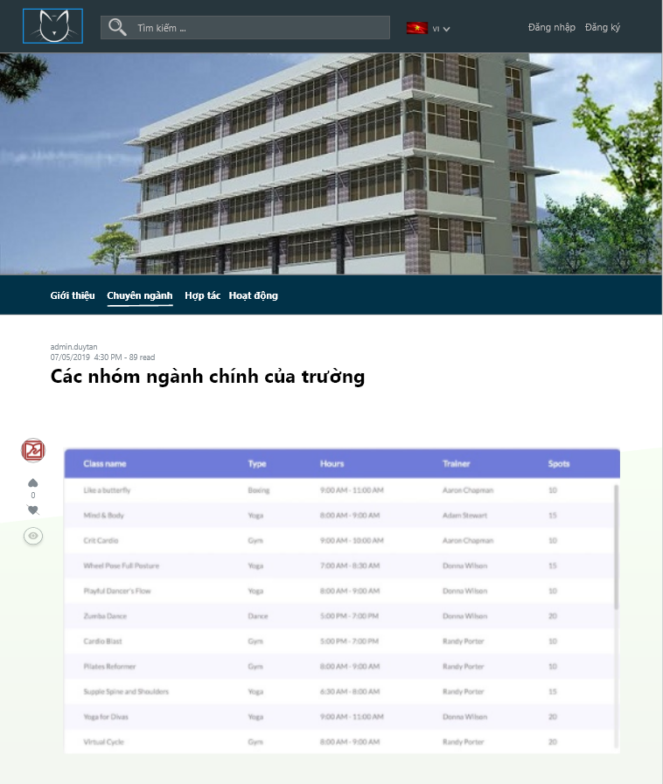

|  |  |  |  |  |  |
| --- | --- | --- | --- | --- | --- |
| **ID** | **Condition** | **Null** | **Control Type** | **Target** | **Notes** |
| 1 | Click |  | Link | All activities are held at the university |  |
| 2 | Click |  | Link | An overview of the university |  |
| 3 | Click |  | Link | Cooperation programs |  |

### 1.8 Cooperation page

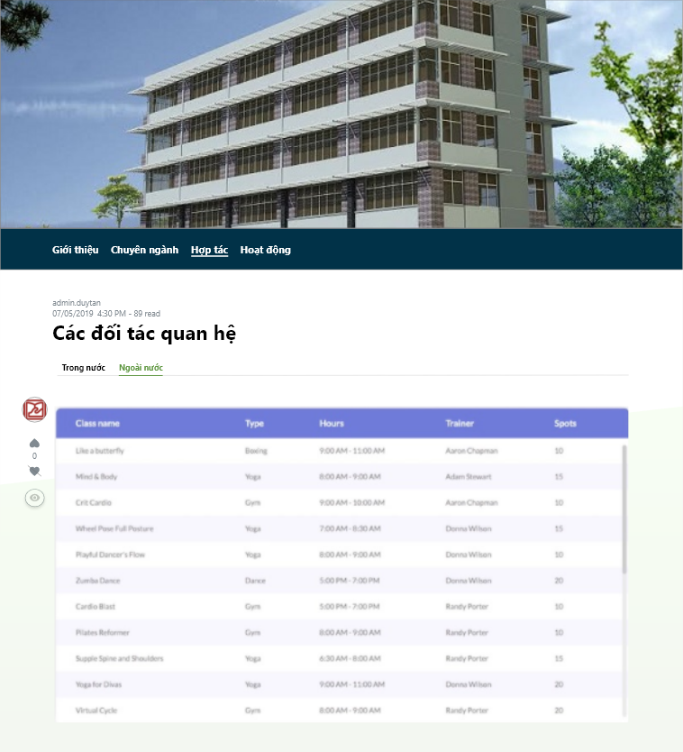

|  |  |  |  |  |  |
| --- | --- | --- | --- | --- | --- |
| **ID** | **Condition** | **Null** | **Control Type** | **Target** | **Notes** |
| 1 | Click |  | Link | All activities are held at the university |  |
| 2 | Click |  | Link | An overview of the university |  |
| 3 | Click |  | Link | The specialized university admission training |  |
| 4 | Click |  | Tab | See cooperation with domestic and foreign partners | Users click on "Trong nước" to see universities linking with domestic partners, users click "Ngoài nước" when they want to see universities linking with foreign partners. |

### 1.9 Gallery page

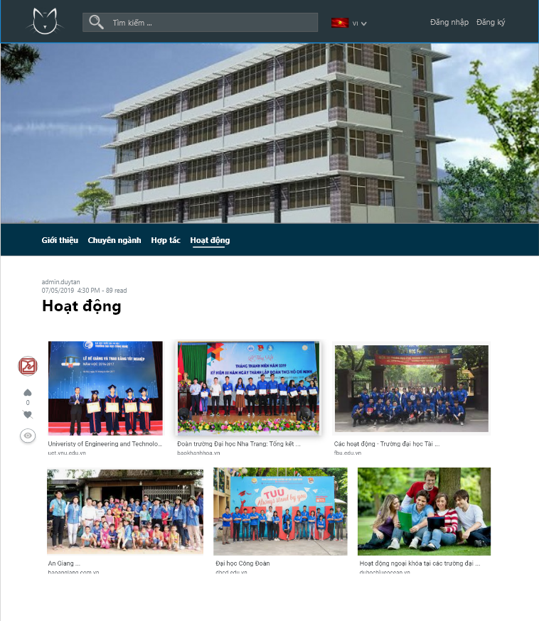

|  |  |  |  |  |  |
| --- | --- | --- | --- | --- | --- |
| **ID** | **Condition** | **Null** | **Control Type** | **Target** | **Notes** |
| 1 | Click |  | Link | Cooperation programs |  |
| 2 | Click |  | Link | An overview of the university |  |
| 3 | Click |  | Link | The specialized university admission training |  |

### 1.10 Topic detail page

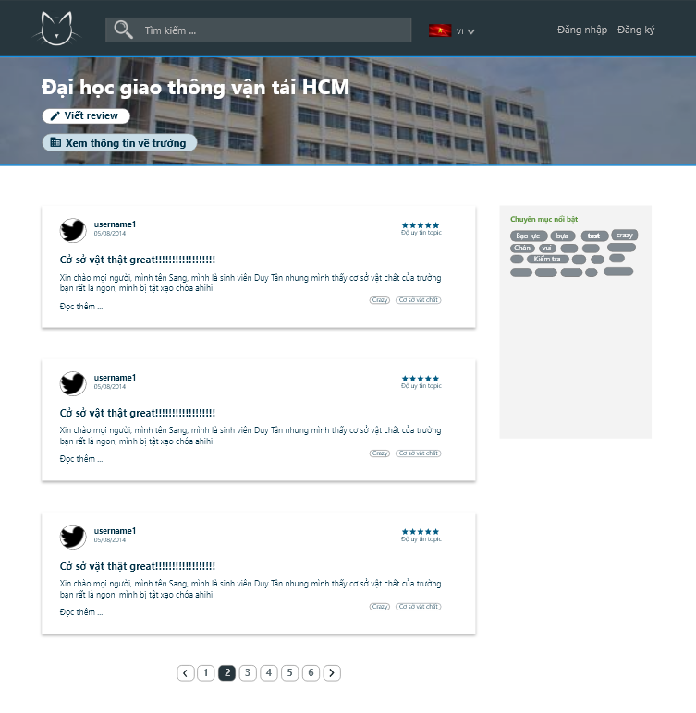

|  |  |  |  |  |  |
| --- | --- | --- | --- | --- | --- |
| **ID** | **Condition** | **Null** | **Control Type** | **Target** | **Notes** |
| 1 | Click |  | Button | Write a review |  |
| 2 | Click |  | Topic | The content reviews about the school |  |
| 3 | Click |  | Button | Choose the content related to the review |  |
| 4 | Click |  | Text | Select Keyword |  |
| 5 | Click |  | Button | Move to the next page or back or move to the required page number | The user who wants to see more about the fields currently displayed on the home page or to return to the old page choose "next" or "previous" |

### 1.12 Comment page

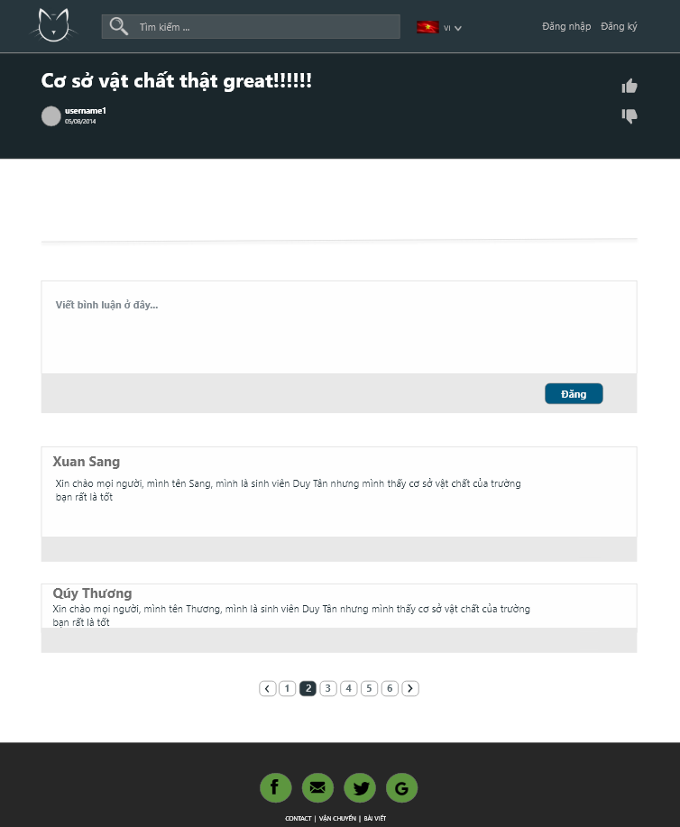

|  |  |  |  |  |  |
| --- | --- | --- | --- | --- | --- |
| **ID** | **Condition** | **Null** | **Control Type** | **Target** | **Notes** |
| 1 | Click |  | Text box | Write a comment |  |
| 2 | Click |  | Button | Post comment |  |
| 2 | Click |  | Icon | Like or dislike topic |  |
| 3 | Click |  | Button | Move to the next page or back or move to the required page number | The user who wants to see more about the fields currently displayed on the home page or to return to the old page choose "next" or "previous" |

### 1.13 Post topic page

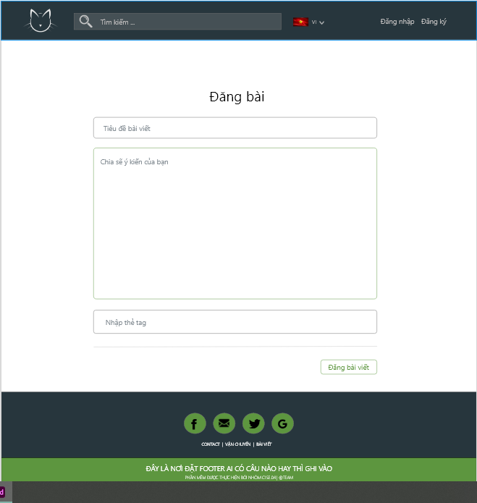

|  |  |  |  |  |  |
| --- | --- | --- | --- | --- | --- |
| **ID** | **Condition** | **Null** | **Control Type** | **Target** | **Notes** |
| 1 | Click |  | Text box | Enter the article title |  |
| 2 | Click |  | Text box | Enter content |  |
| 2 | Click |  | Text box | Enter tag |  |
| 3 | Click |  | Button | Post topic |  |

### 1.14 Edit personal information

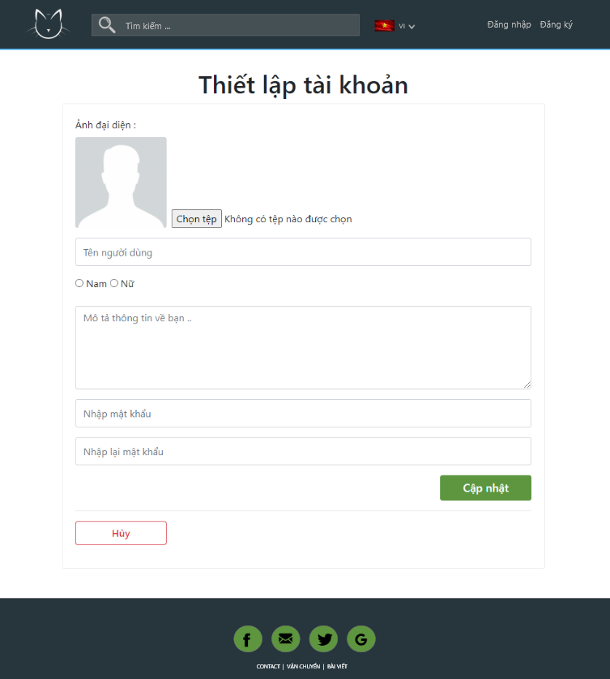

|  |  |  |  |  |  |
| --- | --- | --- | --- | --- | --- |
| **ID** | **Condition** | **Null** | **Control Type** | **Target** | **Notes** |
| 1 | Click |  | Button | Load images |  |
| 2 | Click |  | Text Box | Change name |  |
| 3 | Click |  | Text Box | Personal information Description |  |
| 4 | Click |  | Text Box | Enter new password |  |
| 5 | Click |  | Text Box | Confirm password |  |
| 6 | Click |  | Button | Update account information |  |

### 1.15 Personal page

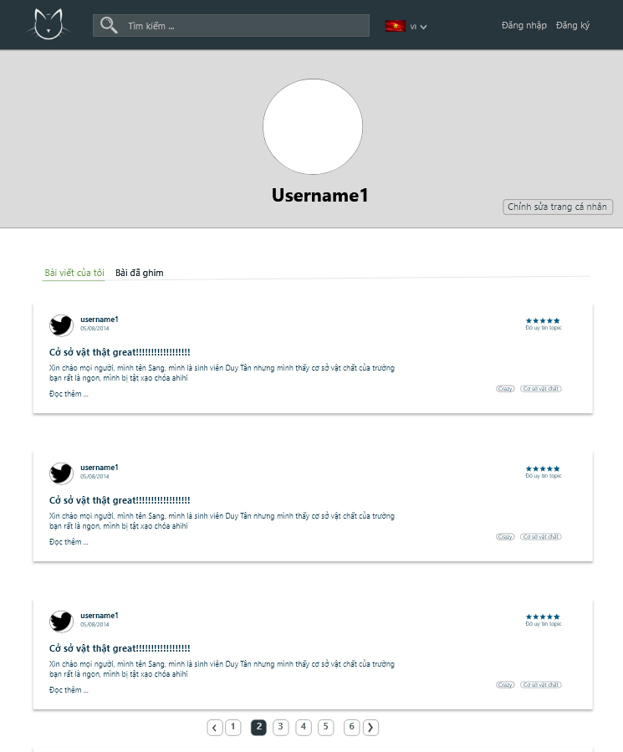

|  |  |  |  |  |  |
| --- | --- | --- | --- | --- | --- |
| **ID** | **Condition** | **Null** | **Control Type** | **Target** | **Notes** |
| 1 | Click |  | Link | Edit personal information |  |
| 2 | Click |  | Tab | View all my posts |  |
| 3 | Click |  | Tab | View the articles I have pinned |  |
| 4 | Click |  | Button | Move to the next page or back or move to the required page number | The user who wants to see more about the fields currently displayed on the home page or to return to the old page choose "next" or "previous" |

1. **University**

### 2.1 Login

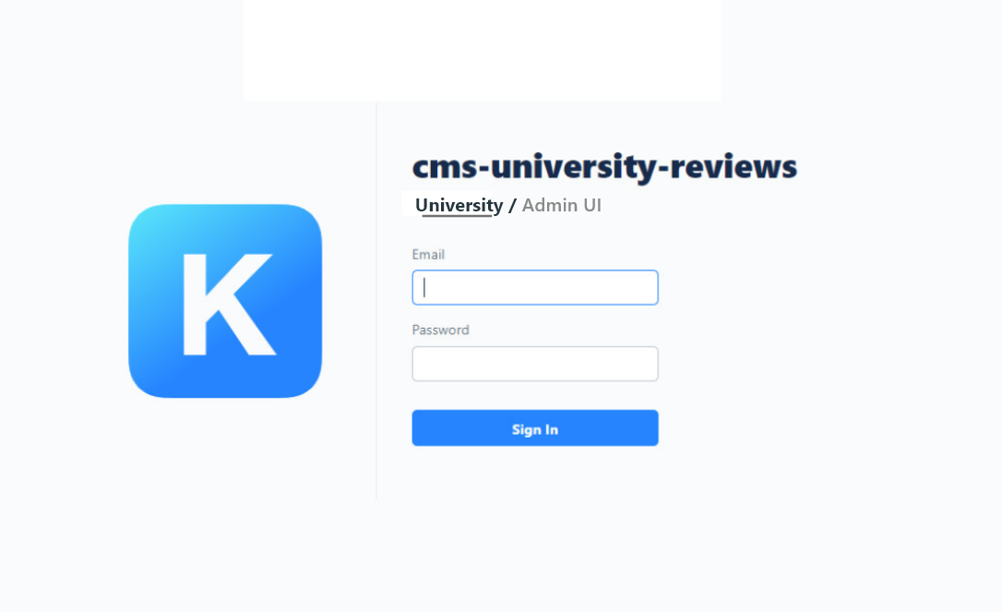

|  |  |  |  |  |  |
| --- | --- | --- | --- | --- | --- |
| **ID** | **Condition** | **Null** | **Control Type** | **Target** | **Notes** |
| 1 | Click |  | Text Box | Enter email |  |
| 2 | Click |  | Password | Enter password |  |
| 3 | Click |  | Button | Login the main page |  |
| 4 | Click |  | Link | Move to Admin page | If you are the administrator of the system, click here “Admin UI” |

### 2.2 Main page university

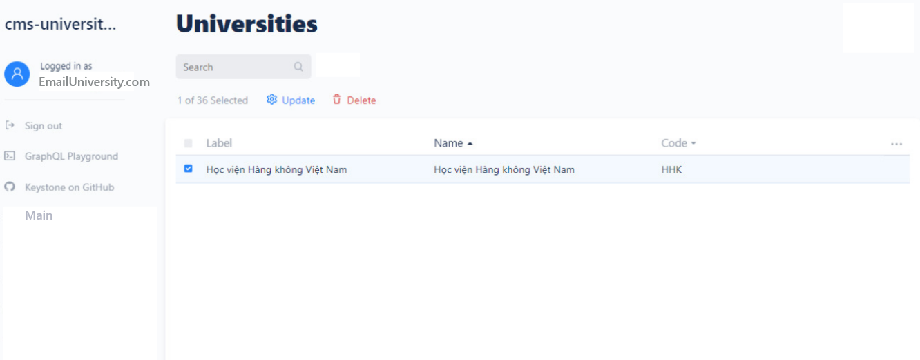

|  |  |  |  |  |  |
| --- | --- | --- | --- | --- | --- |
| **ID** | **Condition** | **Null** | **Control Type** | **Target** | **Notes** |
| 1 | Click |  | Text Box | Search | Search for the content on the page |
| 2 | Click |  | Button Update | Edit, update information |  |
| 3 | Click |  | Button Delete | Delete information |  |
| 4 | Click |  | Row | View details or edit information |  |
| 5 | Click |  | Link | Return to the main page |  |
| 6 | Click |  | Link | Logout account |  |

### 2.3 Edit information

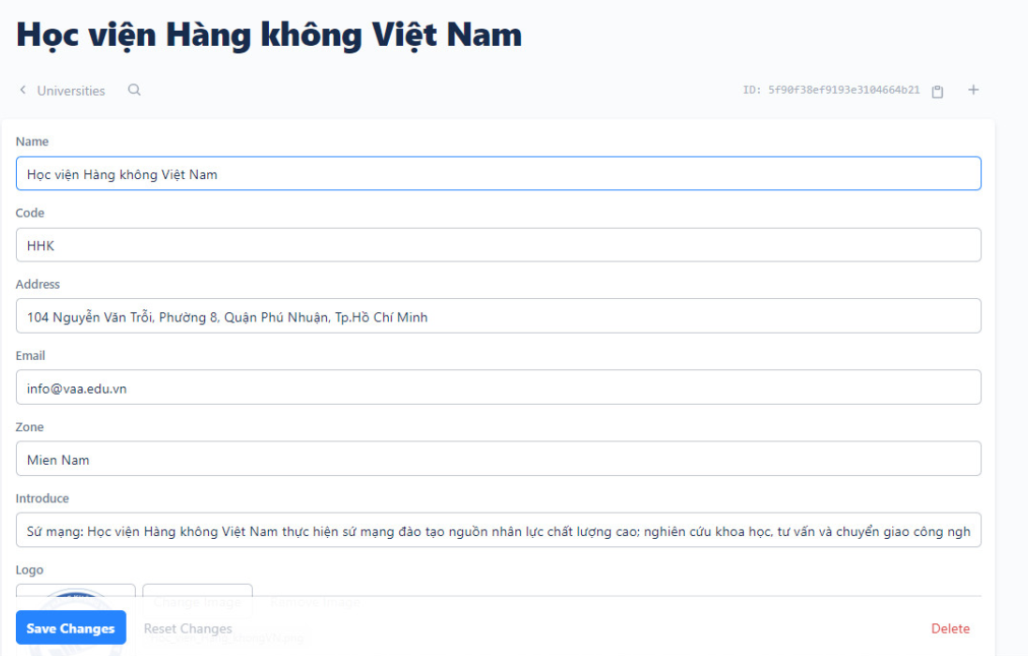

|  |  |  |  |  |  |
| --- | --- | --- | --- | --- | --- |
| **ID** | **Condition** | **Null** | **Control Type** | **Target** | **Notes** |
| 1 | Click |  | Text Box | Enter name university |  |
| 2 | Click |  | Text Box | Enter code of university |  |
| 3 | Click |  | Text Box | Enter Address |  |
| 4 | Click |  | Drop down | Select Zone |  |
| 5 | Click |  | Text Box | Enter introduct/Information of University |  |
| 6 | Click |  | Image | Upload logo |  |
| 7 | Click |  | Button | Save change |  |
| 8 | Click |  | Button | Reset change |  |
| 9 | Click |  | Delete | Delete content need show |  |
| 10 | Click |  | Text Box | Search content in page |  |

1. **Admin**

### 3.1 Login



|  |  |  |  |  |  |
| --- | --- | --- | --- | --- | --- |
| **ID** | **Condition** | **Null** | **Control Type** | **Target** | **Notes** |
| 1 | Click |  | Text Box | Enter email |  |
| 2 | Click |  | Password | Enter password |  |
| 3 | Click |  | Button | Login the system |  |
| 4 | Click |  | Link | Move to Admin University page | If you are the administrator of the university, click here “University” |

### 3.2 Manage account

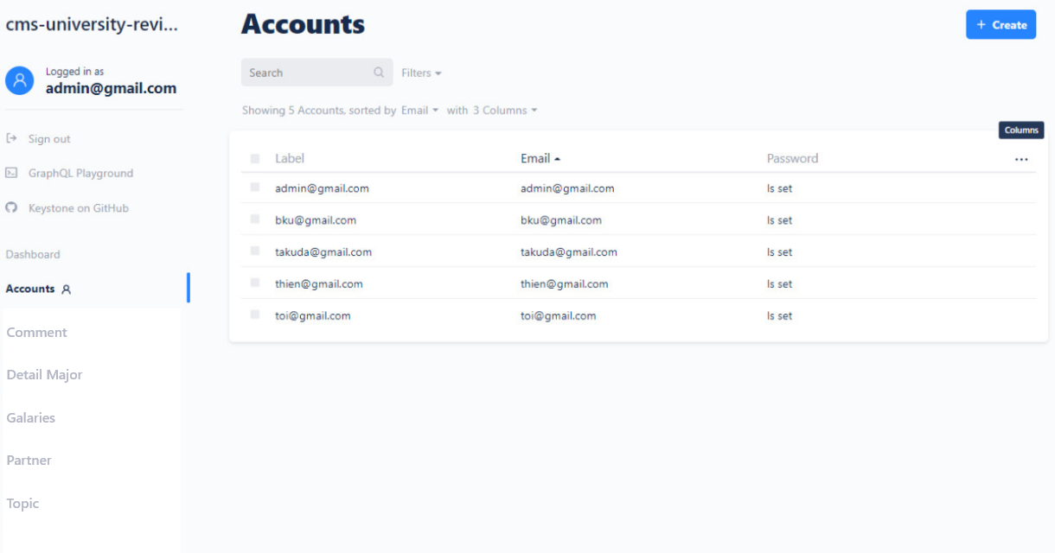

|  |  |  |  |  |  |
| --- | --- | --- | --- | --- | --- |
| **ID** | **Condition** | **Null** | **Control Type** | **Target** | **Notes** |
| 1 | Click |  | Text Box | Search |  |
| 2 | Click |  | Dropbox | Choose by filter |  |
| 3 | Click |  | Row | View or edit an account |  |
| 4 | Click |  | Button | Create account |  |
| 5 | Click |  | Link | Go to manage comment page |  |
| 6 | Click |  | Link | Go to manage detail major page |  |
| 7 | Click |  | Link | Go to manage gallery page |  |
| 8 | Click |  | Link | Go to manage gallery page |  |
| 9 | Click |  | Link | Go to manage topic page |  |
| 10 | Click |  | Link | Logout account |  |

### 3.3 Manage comment

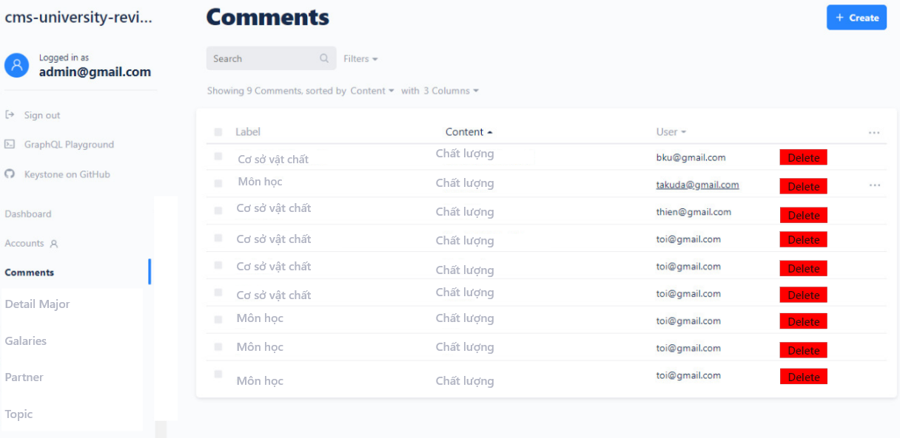

|  |  |  |  |  |  |
| --- | --- | --- | --- | --- | --- |
| **ID** | **Condition** | **Null** | **Control Type** | **Target** | **Notes** |
| 1 | Click |  | Button | Delete comment |  |
| 2 | Click |  | Row | View comment |  |

### 3.4 Manage galaries

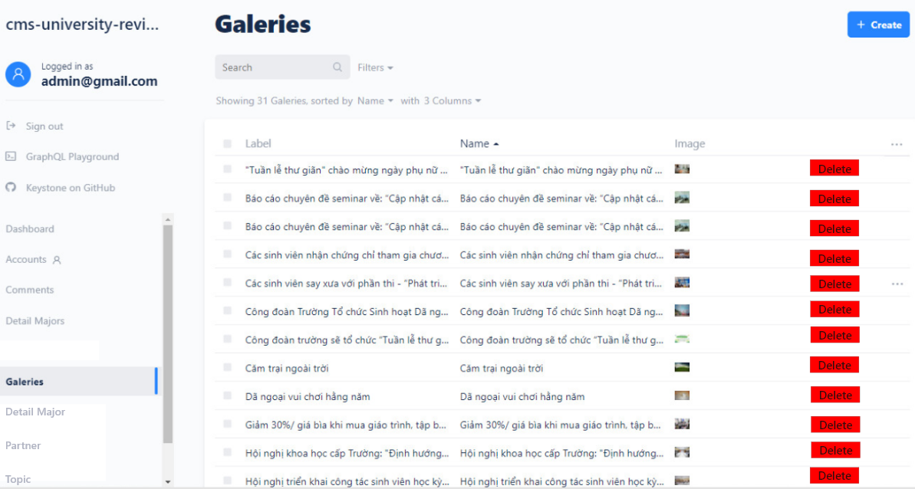

|  |  |  |  |  |  |
| --- | --- | --- | --- | --- | --- |
| **ID** | **Condition** | **Null** | **Control Type** | **Target** | **Notes** |
| 1 | Click |  | Row | View action of university |  |
| 2 | Click |  | Button | Delete row |  |

### 3.5 Manage partners

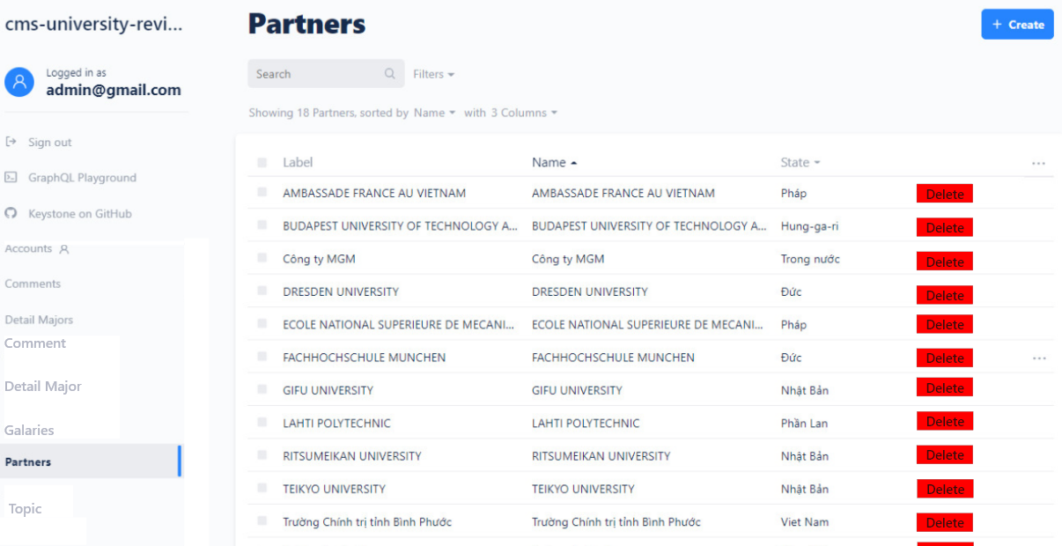

|  |  |  |  |  |  |
| --- | --- | --- | --- | --- | --- |
| **ID** | **Condition** | **Null** | **Control Type** | **Target** | **Notes** |
| 1 | Click |  | Row | View partners of university |  |
| 2 | Click |  | Button | Delete row |  |

### 3.6 Manage topic

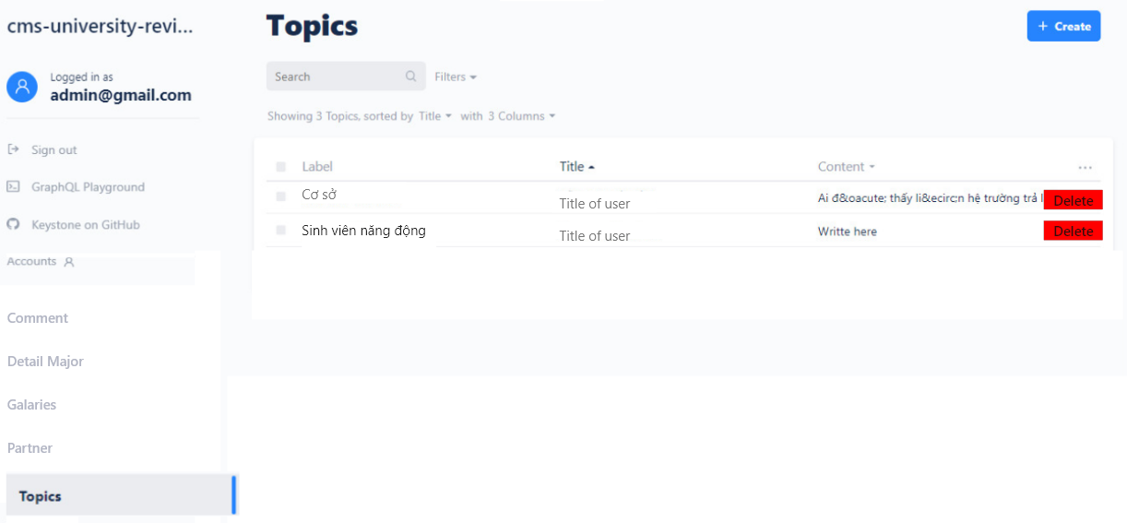

|  |  |  |  |  |  |
| --- | --- | --- | --- | --- | --- |
| **ID** | **Condition** | **Null** | **Control Type** | **Target** | **Notes** |
| 1 | Click |  | Row | View topic of university |  |
| 2 | Click |  | Button | Delete row |  |

### 3.7 Creat account

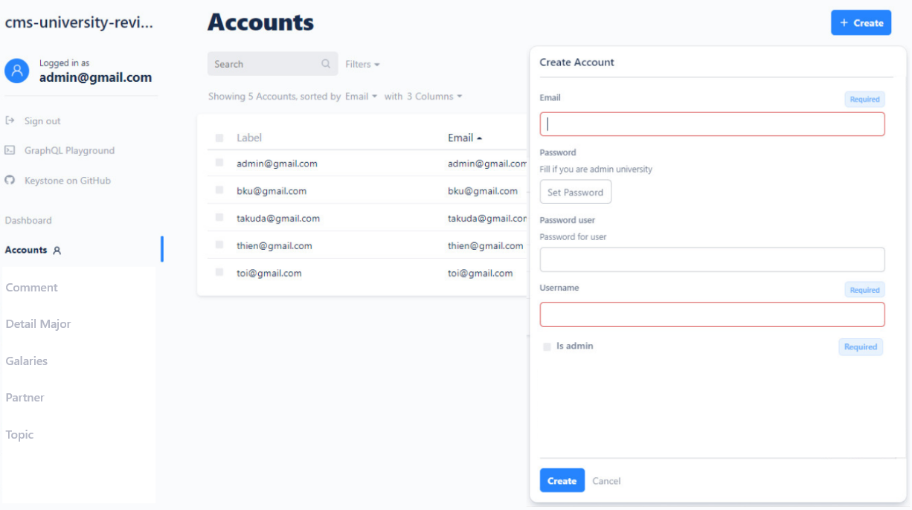

|  |  |  |  |  |  |
| --- | --- | --- | --- | --- | --- |
| **ID** | **Condition** | **Null** | **Control Type** | **Target** | **Notes** |
| 1 | Click |  | Text Box | Enter email |  |
| 2 | Click |  | Button | Set password | If is Admin University |
| 3 | Click |  | Text Box | Enter password | If is User |
| 4 | Click |  | Text Box | Enter user name |  |
| 5 | Click |  | Check Box | Select | Select as the system admin |
| 6 | Click |  | Button | Create |  |
| 7 | Click |  | Button | Cancel |  |